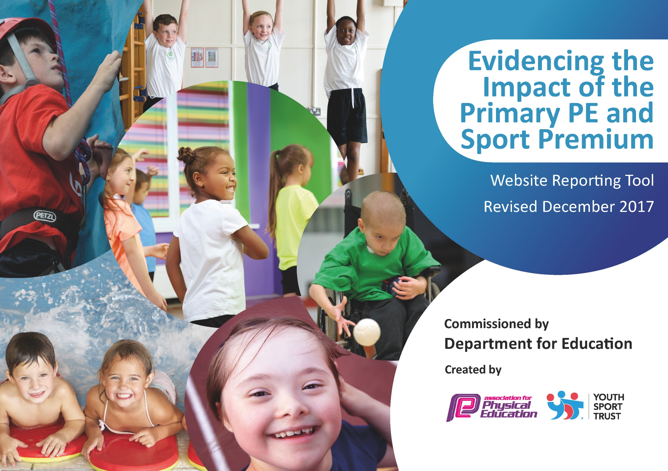

Schools must use the funding to make additional and sustainable improvements to the quality of PE and sport they offer. This means that you should use the Primary PE and Sport Premium to:

- develop or add to the PE and sport activities that your school already offers
- build capacity and capability within the school to ensure that improvements made now will benefit pupils joining the school in future years

Please visit gov.uk for the revised DfE guidance including the 5 key indicators across which schools should demonstrate an improvement. This document will help you to review your provision and to report your spend. DfE encourages schools to use this template as an effective way of meeting the reporting requirements of the Primary PE and Sport Premium.

We recommend you start by reflecting on the impact of current provision and reviewing the previous spend.
Under the Ofsted Schools Inspection Framework, inspectors will assess how effectively leaders use
the Primary PE and Sport Premium and measure its impact on outcomes for pupils, and how effectively governors hold them to account
for this.

Schools are required to publish details of how they spend this funding as well as on the impact it has on pupils’ PE
and sport participation and attainment.
We recommend regularly updating the table and
publishing it on your website as evidence
of your ongoing review into how you are using the money
to secure maximum, sustainable impact. To see an example of how to complete the table please click HERE.

Support for review and reflection - considering the 5 key indicators from DfE, what development needs are a priority for your setting and your students now and why? Use the space below to reflect on previous spend, identify current need and priorities for the future.

Key achievements to date: | Areas for further improvement and baseline evidence of need:
Providing a range of different sports to interest different pupils.  Improving CPD through having a sports coach.  Sports week.  Silver Sports mark award. | Getting more children involved who do not show a passion for sport.  More involvement in competitive sport.

Meeting national curriculum requirements for swimming and water safety | Please complete all of the below*:
What percentage of your current Year 6 cohort swim competently, confidently and proficiently over a distance of at least 25 metres? | 90%
What percentage of your current Year 6 cohort use a range of strokes effectively [for example, front crawl, backstroke and breaststroke]? | 50%
What percentage of your current Year 6 cohort perform safe self-rescue in different water-based situations? | 100%
Schools can choose to use the Primary PE and Sport Premium to provide additional provision for swimming but this must be for activity over and above the national curriculum requirements. Have you used it in this way? | Yes/No
*Schools may wish to provide this information in April, just before the publication deadline.

Action Plan and Budget Tracking
Capture your intended annual spend against the 5 key indicators. Clarify the success criteria and evidence of impact that you intend to measure to evaluate for students today and for the future.

Academic Year: 2017/18 | Total fund allocated: £1235 | Date Updated:July 2018
Key indicator 1: The engagement of all pupils in regular physical activity – Chief Medical Officer guidelines recommend that primary school children undertake at least 30 minutes of physical activity a day in school |  |  |  | Percentage of total allocation:
 |  |  |  | 9%
School focus with clarity on intended impact on pupils: | Actions to achieve: | Funding allocated: | Evidence and impact: | Sustainability and suggested next steps:
Children to walk a daily mile, to increase regular physical activity. | All children to be out walking/running each day for 15 minutes. | £1235 | Weather dependent – when the grass was too muddy we couldn’t get on. We have since had a path built to get on the track. Improves concentration in lessons for brain breaks and increases daily physical activity. | Needs to be more consistent through school – still working on.
Key indicator 2: The profile of PE and sport being raised across the school as a tool for whole school improvement |  |  |  | Percentage of total allocation:
 |  |  |  | %
School focus with clarity on intended impact on pupils: | Actions to achieve: | Funding allocated: | Evidence and impact: | Sustainability and suggested next steps:

Key indicator 3: Increased confidence, knowledge and skills of all staff in teaching PE and sport |  |  |  | Percentage of total allocation:
 |  |  |  | 70%
School focus with clarity on intended  impact on pupils: | Actions to achieve: | Funding  allocated: | Evidence and impact: | Sustainability and suggested  next steps:
Sports coach - PE lessons will be well structured and teachers will have a good understanding of how to progress high ability children. | Team teaching with Mark.  Observing PE coach. | £9792 | Teachers feel confident to teach PE across the school. They have a clear focus and are able to effectively plan lessons for all children. Including highlighted children with a passion/skill for a particular sport. | Continuing next year to imrove CPD further – more team teaching with Mark. Mark observing teachers teaching PE.
Key indicator 4: Broader experience of a range of sports and activities offered to all pupils |  |  |  | Percentage of total allocation:
 |  |  |  | 21%
School focus with clarity on intended  impact on pupils: | Actions to achieve: | Funding  allocated: | Evidence and impact: | Sustainability and suggested  next steps:
Sports week – Giving children a taster of all sports to see if they enjoy/have a talent for it.  Healthy eating and the importance of a balanced diet.  Rattle and Roll A street dance class to give children the opportunity to try different areas of PE.  Drumba – a fitness and drumming class for children that do not enjoy PE.  Mark (sports coach) afterschool clubs – giving children the chance to develop skills in a range of sports. | Lots of different people coming in from a range of sports.  Have the opportunity to join a club.  Find out any particular interests children have.  Enjoyment of PE.  An opportunity to discover children who enjoy dance and give them an opportunity to continue this.  Improve children’s fitness.  Enjoyment of PE  Children to develop skills. | Free – people from the community.  £990  £1920  Part of above | Children have found sports they enjoyed and have found different things they enjoy doing. Continued this after sports week.  Improved children’s dance and rhythm – they enjoyed dancing and involved children who do not always want to do PE.  A fun way to keep fit – children’s fitness levels improved.  Children learn new skills and demonstrate these during PE lessons.  Sports decided based on children’s interests. | We will be doing sports week again – the children enjoy it and the level of participation is high. Every day children complete lots of physical activity and this is continued after the week.  Rattle and roll didn’t improve fitness as much as we would like. The children enjoyed it and teaching was good.  children loved Drumba especially children who would not usually fully participate in PE.  The skills learnt have been demonstrated in PE lessons. Can see the improvement it makes.
Key indicator 5: Increased participation in competitive sport |  |  |  | Percentage of total allocation:
 |  |  |  | 1%
School focus with clarity on intended  impact on pupils: | Actions to achieve: | Funding  allocated: | Evidence and impact: | Sustainability and suggested  next steps:
Rushcliffe partnership | Participate in different competitions within rushcliffe.  Have a range of children competing. | £100 | Children enjoy competing in sport.  Teachers run Basketball and Football competitions that are not involved in this.  Only a small number of children choose to compete.  The children who compete feel proud of their achievements – celebrated as a whole school. | To attend more out of school competitions – funding put aside for this.  To have training sessions for the other afterschool clubs.  Encourage other children to take part.

