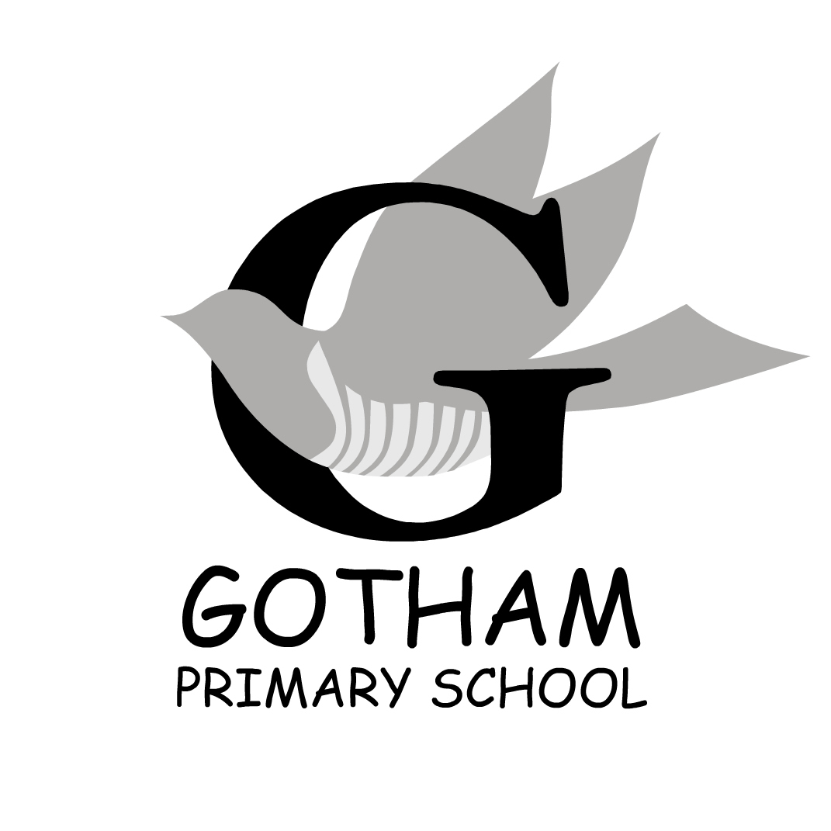
PUPIL ABSENCE
PARENTAL CONFIRMATION FORM
Pupil Reason for Absence
Dear Parent/carer
Your child has been absent from school and we have not received communication of the reason for absence.
Please can you complete and sign the form below.
Name: |  | No. of days off:
Dates of absence: | From: To:
Reason:

Signed: |  | Date:

Please complete and return the above form to the school office as soon as possible or Email ndelfino@gotham.notts .sch.uk

Thank you for your co-operation, this is part of our drive to improve and monitor attendance at school.

Janette Allen
Head Teacher

