Head Teacher Miss Janette Allen

Kegworth Road

Gotham

Nottinghamshire

NG11 0JS

Telephone 0115 9149751

Email: [office@gotham.notts.sch.uk](mailto:office@gotham.notts.sch.uk)

DATE

Dear

**PUPIL ATTENDANCE REVIEW MEETING**

School attendance is a priority for our school and we are constantly monitoring pupil attendance. We want to work together with parents to help ensure excellent attendance and punctuality for all pupils from an early age.

I have noticed that _____________________ has an attendance of _____________. This level of absence has been caused by holidays/illness.

The following information shows how school attendance can affect your child’s future progress.

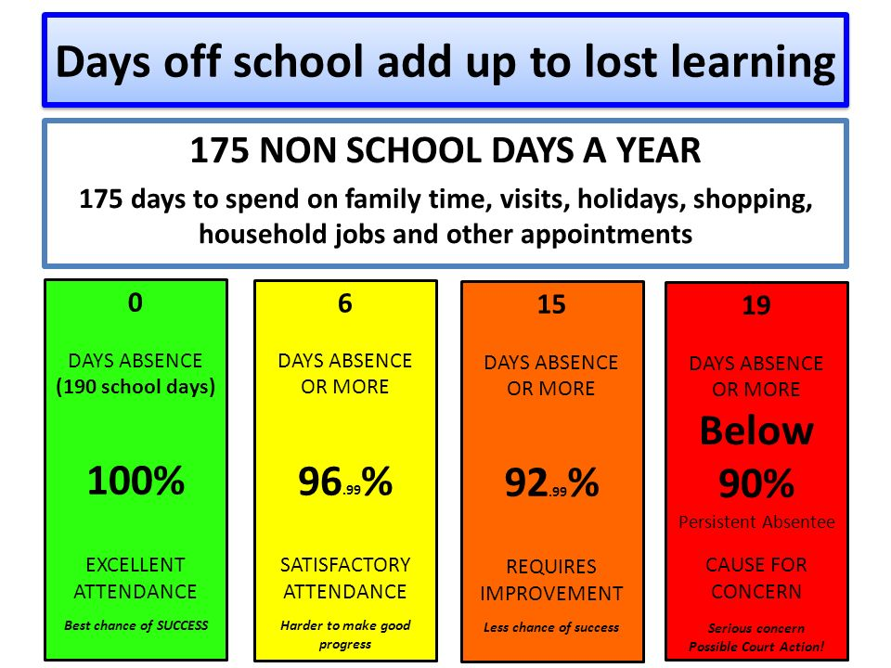

I would like to discuss your child’s attendance with you, please telephone school to make an appointment at your earliest convenience. We will be joined at this meeting by a member of the Governing Body.

Yours sincerely

Janette Allen

Head Teacher